WEEK-7 React
9. ReactJS-HOL
Create a React Application named “cricketapp” with the following components
ListofPlayers.js
import React from 'react';
function ListofPlayers(props) {
return (
props.players.map((item) => {
return (
<div>
<li>Mr. {item.name} <span> {item.score} </span></li>
</div>
);
})
);
}
export default ListofPlayers;
Scorebelow70.js
import React from 'react';
function Scorebelow70(props) {
const players70 = [];
props.players.map((item) => {
if (item.score <= 70) {
players70.push(item);
}
return null;
});
return (
players70.map((item) => {
return (
<div>
<li>Mr. {item.name} <span> {item.score} </span></li>
</div>
);
})
);
}
export default Scorebelow70;
PlayerTeams.js
import React from 'react';
export function OddPlayers([first, , third, , fifth]) {
return (
<div>
<li> First : {first} </li>
<li> Third : {third} </li>
<li> Fifth : {fifth} </li>
</div>
);
}
export function EvenPlayers([, second, , fourth, , sixth]) {
return (
<div>
<li> Second : {second} </li>
<li> Fourth : {fourth} </li>
<li> Sixth : {sixth} </li>
</div>
);
}
PlayersList.js
export const T20Players = ['First Player', 'Second Player', 'Third Player'];
export const RanjiTrophyPlayers = ['Fourth Player', 'Fifth Player', 'Sixth Player'];
export const IndianPlayers = [...T20Players, ...RanjiTrophyPlayers];
ListofIndianPlayers.js
import React from 'react';
function ListofIndianPlayers(props) {
return (
props.IndianPlayers.map((player) => {
return (
<li>Mr. {player}</li>
);
})
);
}
export default ListofIndianPlayers;
App.js
When Flag=true
import React, { Component } from 'react';
import ListofPlayers from './ListofPlayers';
import Scorebelow70 from './Scorebelow70';
import { OddPlayers, EvenPlayers } from './PlayerTeams';
import ListofIndianPlayers from './ListofIndianPlayers';
import { IndianPlayers } from './PlayersList';
class App extends Component {
render() {
var flag = true;
const players = [
{ name: 'Jack', score: 50 },
{ name: 'Michael', score: 70 },
{ name: 'John', score: 40 },
{ name: 'Ann', score: 61 },
{ name: 'Elisabeth', score: 61 },
{ name: 'Sachin', score: 95 },
{ name: 'Dhoni', score: 100 },
{ name: 'Virat', score: 84 },
{ name: 'Jadeja', score: 64 },
{ name: 'Raina', score: 75 },
{ name: 'Rohit', score: 80 }
];
const IndianTeam = ['Sachin1', 'Dhoni2', 'Virat3', 'Rohit4', 'Yuvaraj5', 'Raina6'];
if (flag === true) {
return (
<div>
<h1> List of Players</h1>
<ListofPlayers players={players} />
<hr />
<h1> List of Players having Scores Less than 70 </h1>
<Scorebelow70 players={players} />
</div>
);
} else {
return (
<div>
<div>
<h1> Indian Team </h1>
<h1> Odd Players </h1>
{OddPlayers(IndianTeam)}
<hr />
<h1> Even Players </h1>
{EvenPlayers(IndianTeam)}
</div>
<hr />
<div>
<h1> List of Indian Players Merged: </h1>
<ListofIndianPlayers IndianPlayers={IndianPlayers} />
</div>
</div>
);
}
}
}

export default App;
Output:
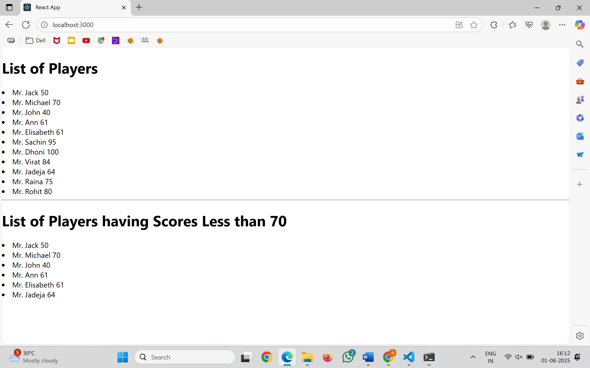
App.js
When Flag=false
import React, { Component } from 'react';
import ListofPlayers from './ListofPlayers';
import Scorebelow70 from './Scorebelow70';
import { OddPlayers, EvenPlayers } from './PlayerTeams';
import ListofIndianPlayers from './ListofIndianPlayers';
import { IndianPlayers } from './PlayersList';
class App extends Component {
render() {
var flag = false;
const players = [
{ name: 'Jack', score: 50 },
{ name: 'Michael', score: 70 },
{ name: 'John', score: 40 },
{ name: 'Ann', score: 61 },
{ name: 'Elisabeth', score: 61 },
{ name: 'Sachin', score: 95 },
{ name: 'Dhoni', score: 100 },
{ name: 'Virat', score: 84 },
{ name: 'Jadeja', score: 64 },
{ name: 'Raina', score: 75 },
{ name: 'Rohit', score: 80 }
];
const IndianTeam = ['Sachin1', 'Dhoni2', 'Virat3', 'Rohit4', 'Yuvaraj5', 'Raina6'];
if (flag === true) {
return (
<div>
<h1> List of Players</h1>
<ListofPlayers players={players} />
<hr />
<h1> List of Players having Scores Less than 70 </h1>
<Scorebelow70 players={players} />
</div>
);
} else {
return (
<div>
<div>
<h1> Indian Team </h1>
<h1> Odd Players </h1>
{OddPlayers(IndianTeam)}
<hr />
<h1> Even Players </h1>
{EvenPlayers(IndianTeam)}
</div>
<hr />
<div>
<h1> List of Indian Players Merged: </h1>
<ListofIndianPlayers IndianPlayers={IndianPlayers} />
</div>
</div>
);
}
}
}
export default App;
Output:
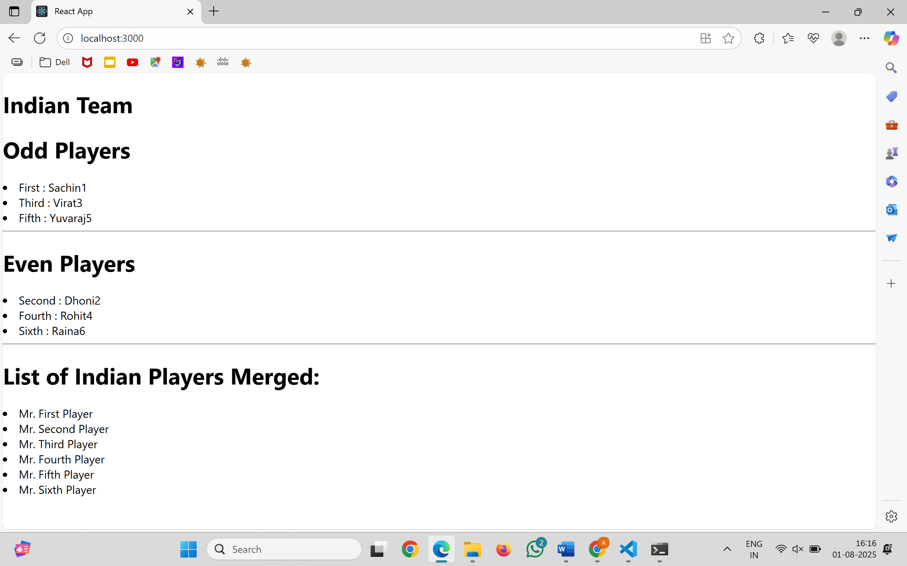

10. ReactJS-HOL
Create a React Application named “officespacerentalapp” which uses React JSX to create elements, attributes and renders DOM to display the page.
App.js
import React from 'react';
import sr from './officeimg.jpg';
import './App.css';
function App() {
const element = "Office Space";
const jsxatt = <img src={sr} width="25%" height="25%" alt="Office Space" />;
const ItemName = {
Name: "DBS",
Rent: 50000,
Address: "Chennai"
};
const rentClass = ItemName.Rent <= 60000 ? "textRed" : "textGreen";
return (
<div>
<h1>{element}, at Affordable Range</h1>
{jsxatt}
<h1>Name: {ItemName.Name}</h1>
<h3 className={rentClass}>Rent: Rs. {ItemName.Rent}</h3>
<h3>Address: {ItemName.Address}</h3>
</div>
);
}
export default App;
App.css
.textRed {
color: red;
}
.textGreen {
color: green;
}

officeimg.jpg

Output:
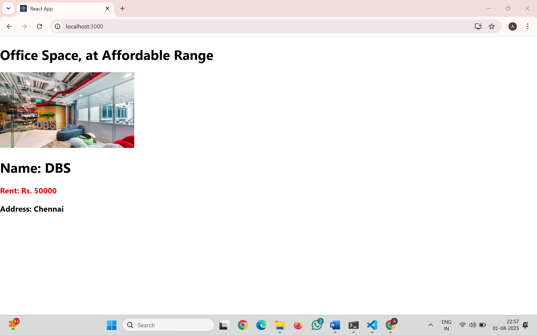
11. ReactJS-HOL
Create a React Application “eventexamplesapp” to handle various events of the form elements in HTML.
Counter.js
import React, { Component } from 'react';
class Counter extends Component {
constructor(props) {
super(props);
this.state = {
count: 0
};
}
increment = () => {
this.setState({ count: this.state.count + 1 });
}
sayHello = () => {
alert("Hello! Member");
}
incrementAndGreet = () => {
this.increment();
this.sayHello();
}
decrement = () => {
this.setState({ count: this.state.count - 1 });
}
render() {
return (
<div>
<h2>{this.state.count}</h2>
<button onClick={this.incrementAndGreet}>Increment</button>
<button onClick={this.decrement}>Decrement</button>
</div>
);
}
}
export default Counter;
WelcomeButton.js
import React from 'react';
function WelcomeButton() {
const showMessage = (message) => {
alert(message);
};
return (
<button onClick={() => showMessage("welcome")}>
Say welcome
</button>
);
}
export default WelcomeButton;
SyntheticEventExample.js
import React from 'react';
function SyntheticEventExample() {
const handleClick = (event) => {
alert("I was clicked");
console.log("Synthetic Event:", event);
};
return (
<button onClick={handleClick}>
Click on me
</button>
);
}
export default SyntheticEventExample;

CurrencyConverter.js
import React, { useState } from 'react';
function CurrencyConverter() {
const [rupees, setRupees] = useState('');
const handleSubmit = () => {
const conversionRate = 80;
const convertedAmount = rupees * conversionRate;
alert(`Converting to Euro Amount is ${convertedAmount}`);
};
return (
<div>
<h2 style={{ color: "green" }}>Currency Convertor!!!</h2>
<div>
<label>Amount:</label>
<input
type="number"
value={rupees}
onChange={(e) => setRupees(e.target.value)}
/>
</div>
<div>
<label>Currency:</label>
<textarea value="Euro" readOnly />
</div>
<button onClick={handleSubmit}>Submit</button>
</div>
);
}
export default CurrencyConverter;
App.js
import React from 'react';
import './App.css';
import Counter from './Counter';
import WelcomeButton from './WelcomeButton';
import SyntheticEventExample from './SyntheticEventExample';
import CurrencyConverter from './CurrencyConverter';
function App() {
return (
<div className="App">
<h1>React Event Handling Examples</h1>
<Counter />
<WelcomeButton />
<SyntheticEventExample />
<CurrencyConverter />
</div>
);
}
export default App;
Output:
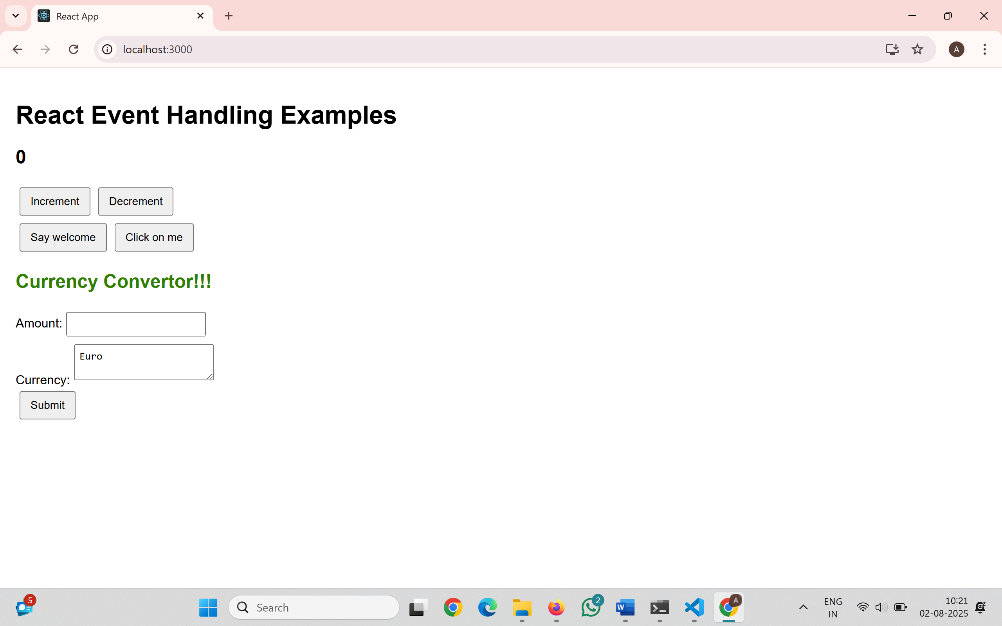
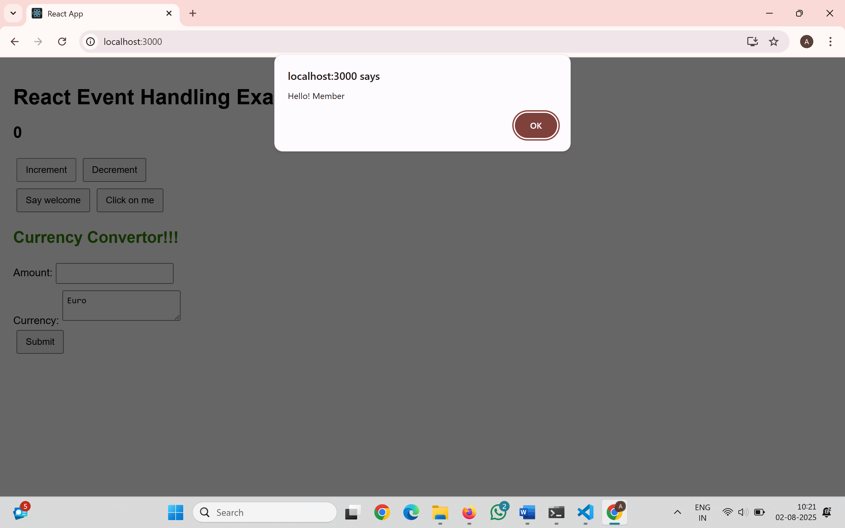
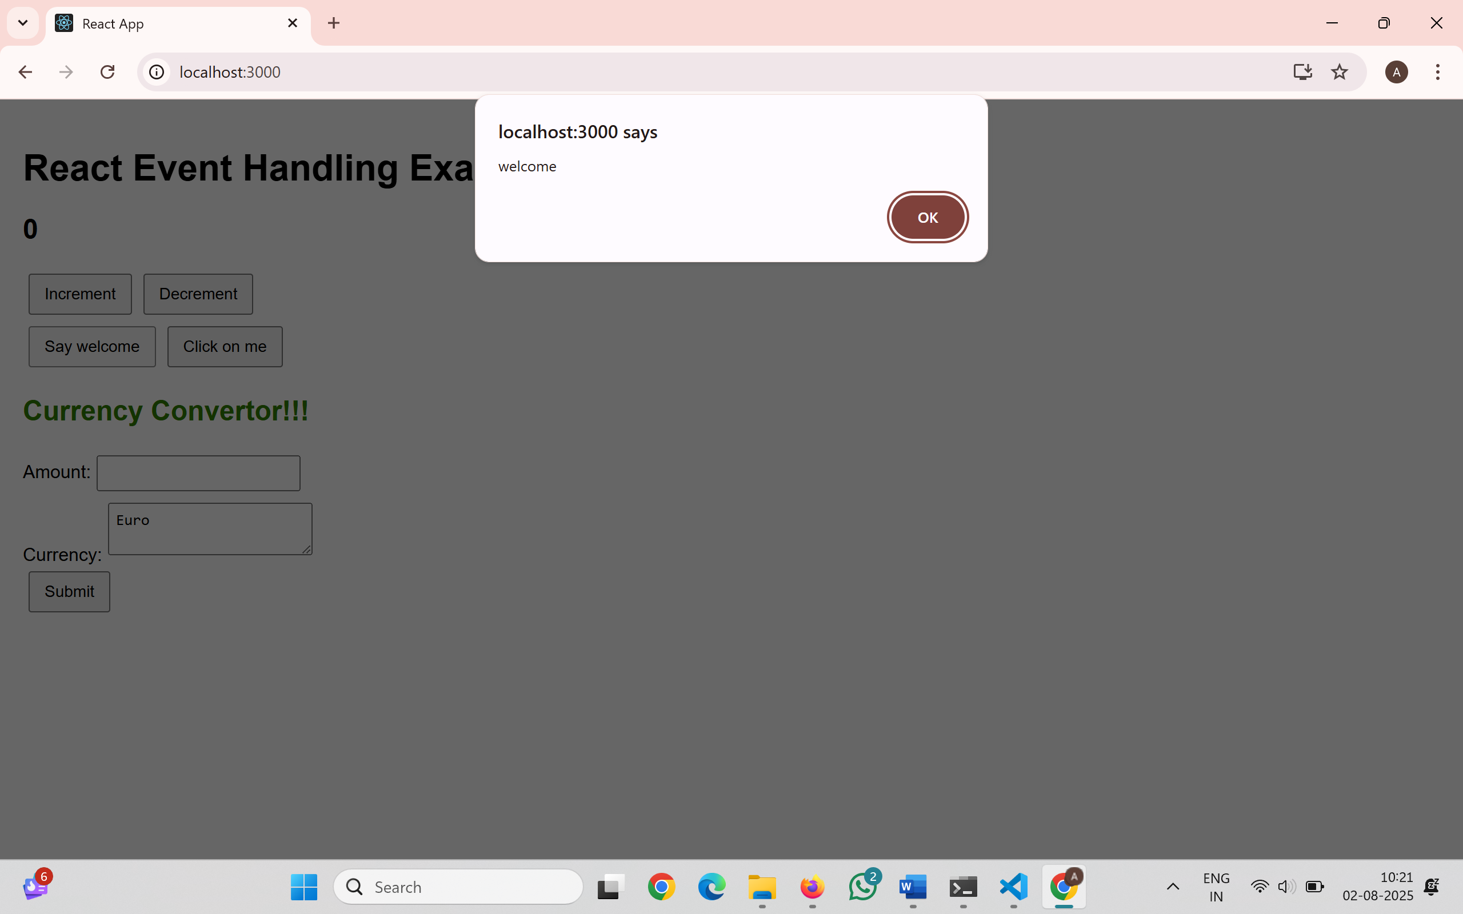
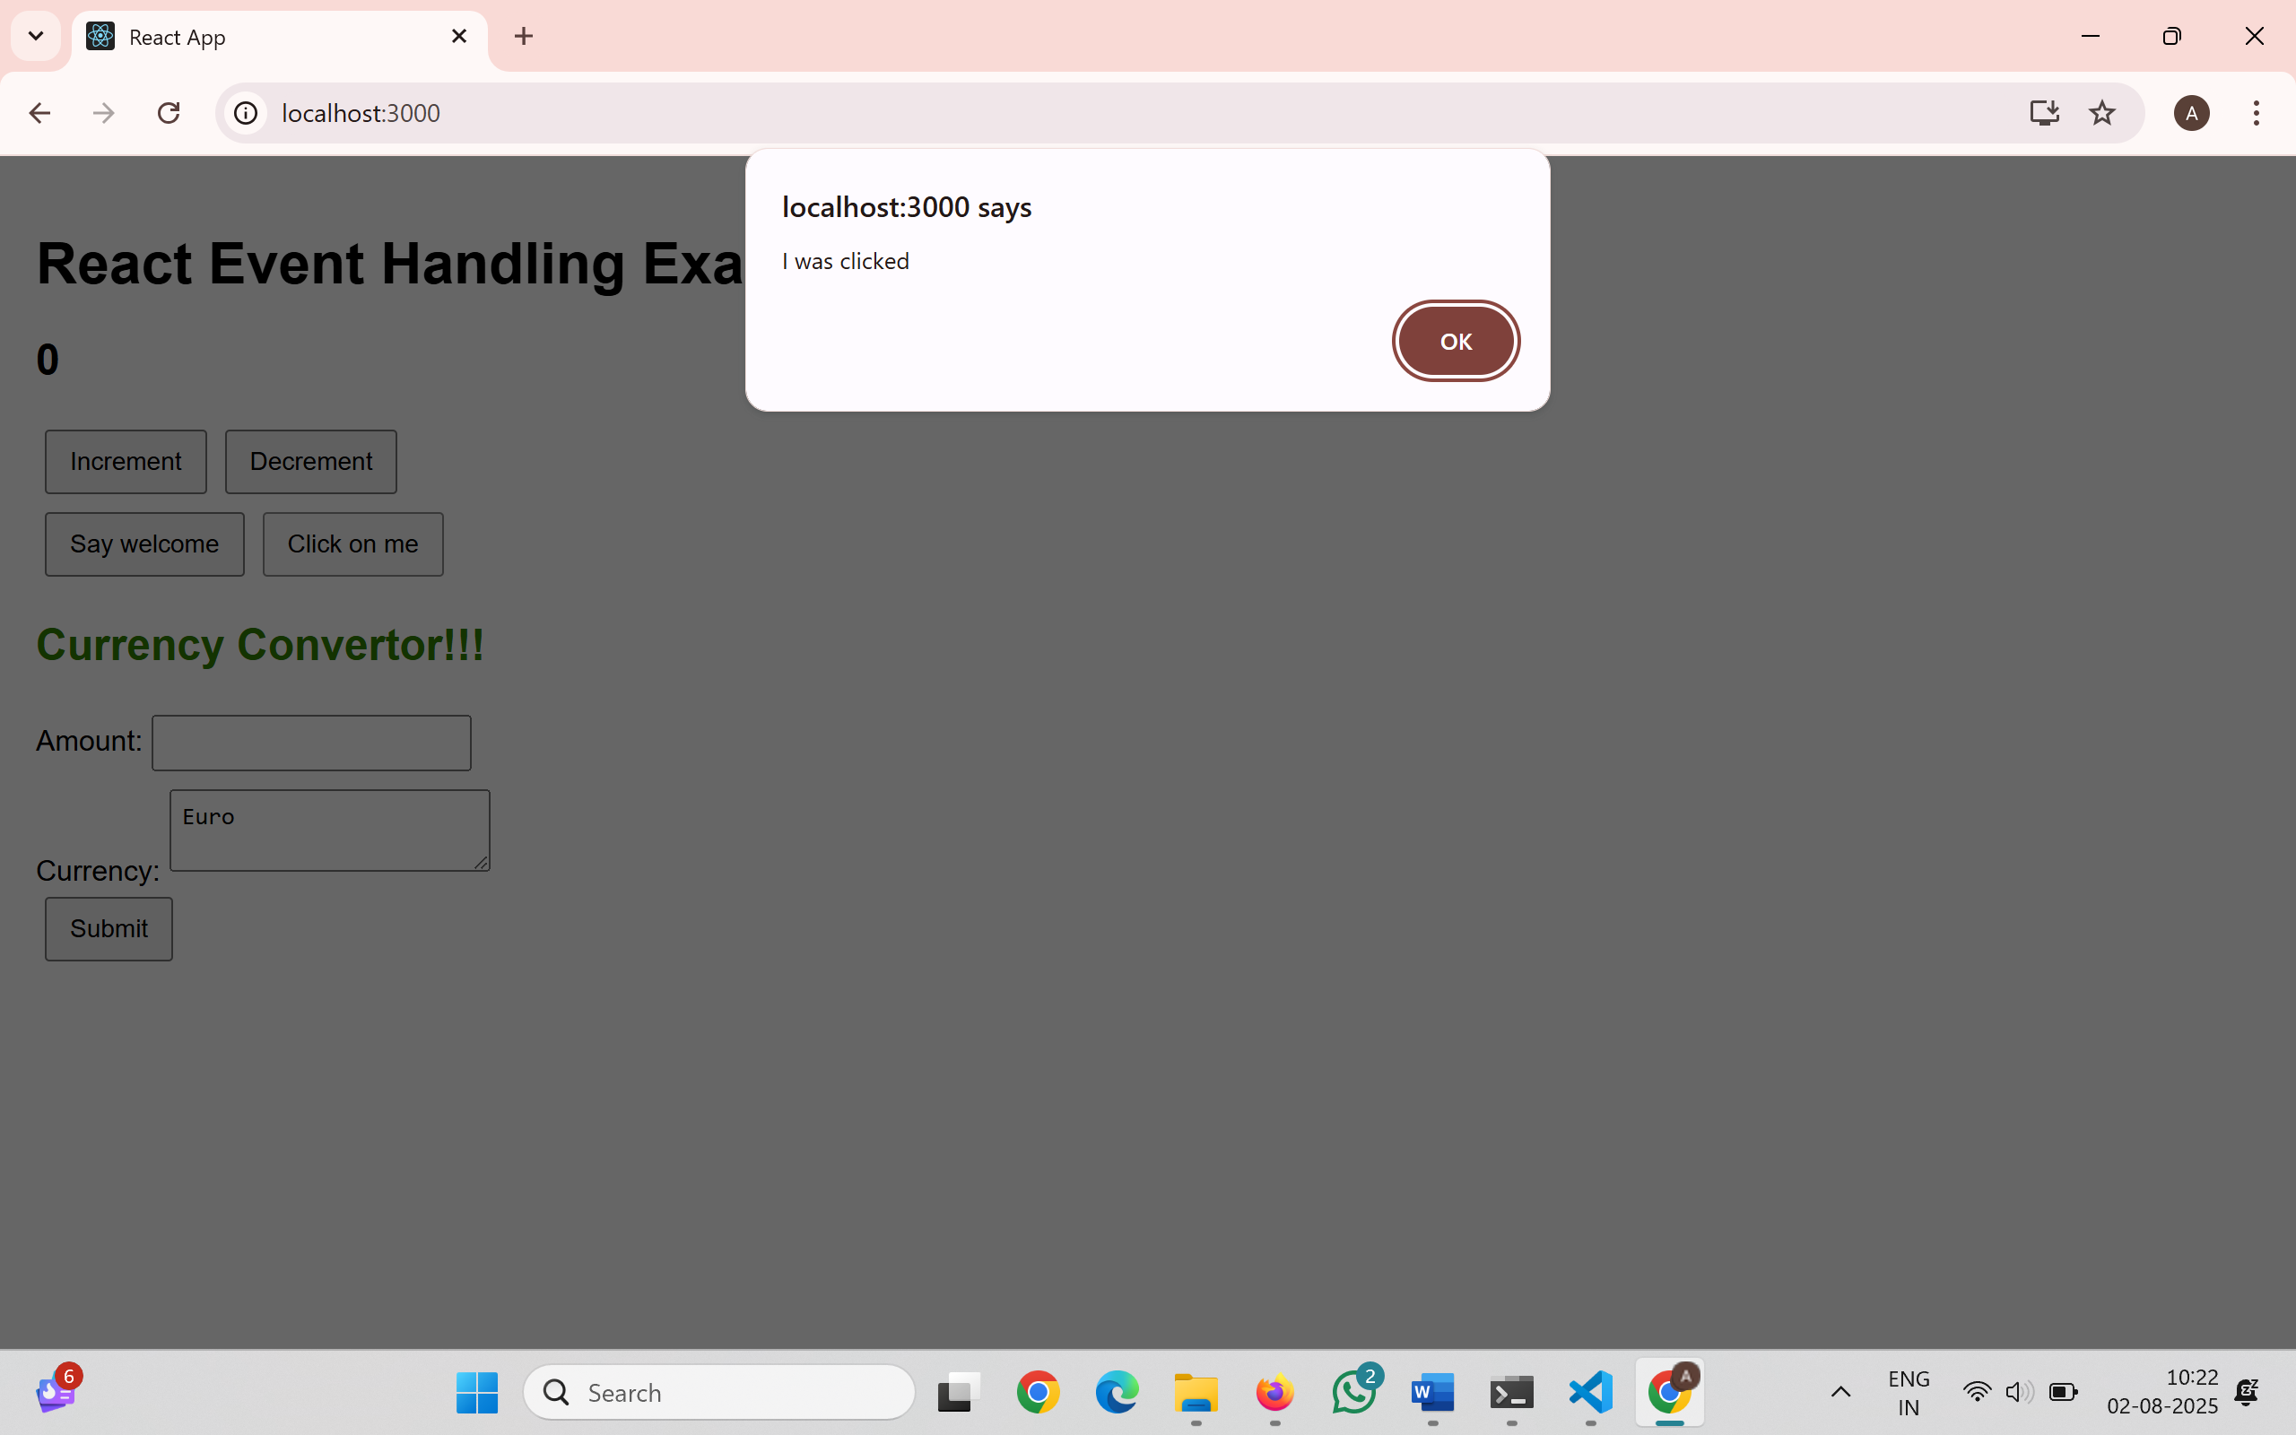
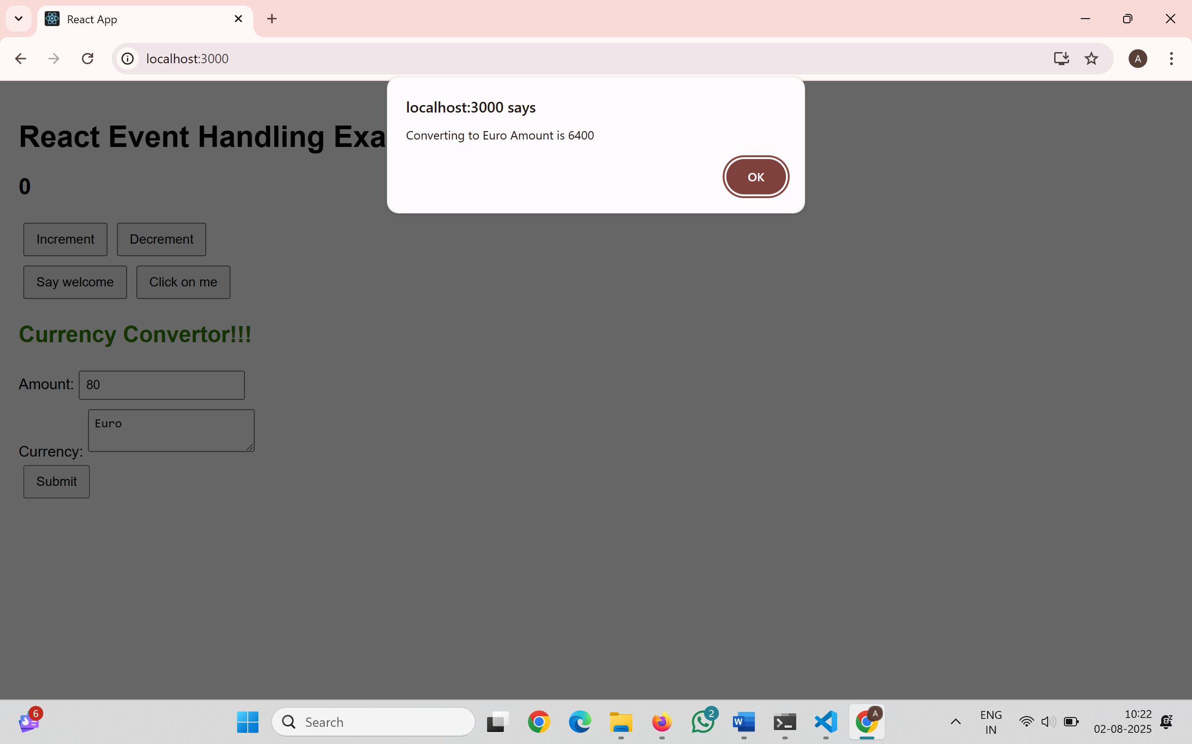
12. ReactJS-HOL
Create a React Application named “ticketbookingapp” where the guest user can browse the page where the flight details are displayed whereas the logged in user only can book tickets.
LoginButton.js
import React from 'react';
function LoginButton(props) {
return (
<button onClick={props.onClick}>
Login
</button>
);
}
export default LoginButton;
LogoutButton.js
import React from 'react';
function LogoutButton(props) {
return (
<button onClick={props.onClick}>
Logout
</button>
);
}
export default LogoutButton;
GuestGreeting.js
import React from 'react';
function GuestGreeting() {
return (
<h1>Please sign up.</h1>
);
}
export default GuestGreeting;
UserGreeting.js
import React from 'react';
function UserGreeting() {
return (
<h1>Welcome back!</h1>
);
}
export default UserGreeting;
Greeting.js
import React from 'react';
import GuestGreeting from './GuestGreeting';
import UserGreeting from './UserGreeting';
function Greeting(props) {
const isLoggedIn = props.isLoggedIn;
if (isLoggedIn) {
return <UserGreeting />;
}
return <GuestGreeting />;
}
export default Greeting;
FlightDetails.js
import React from 'react';
function FlightDetails() {
return (
<div>
<h3>Flight Details</h3>
<ul>
<li>Flight: AI202 - Delhi to Mumbai</li>
<li>Time: 10:00 AM</li>
<li>Duration: 2 Hours</li>
</ul>
</div>
);
}
export default FlightDetails;
Output: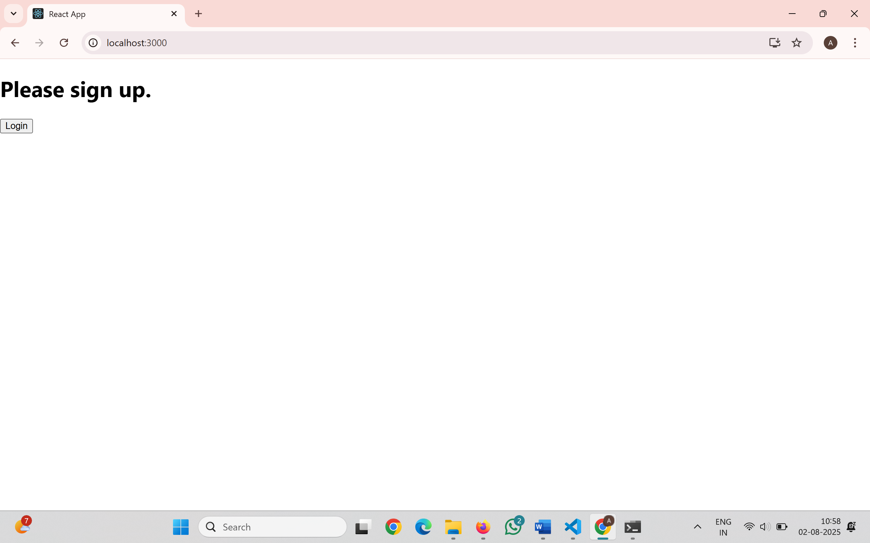
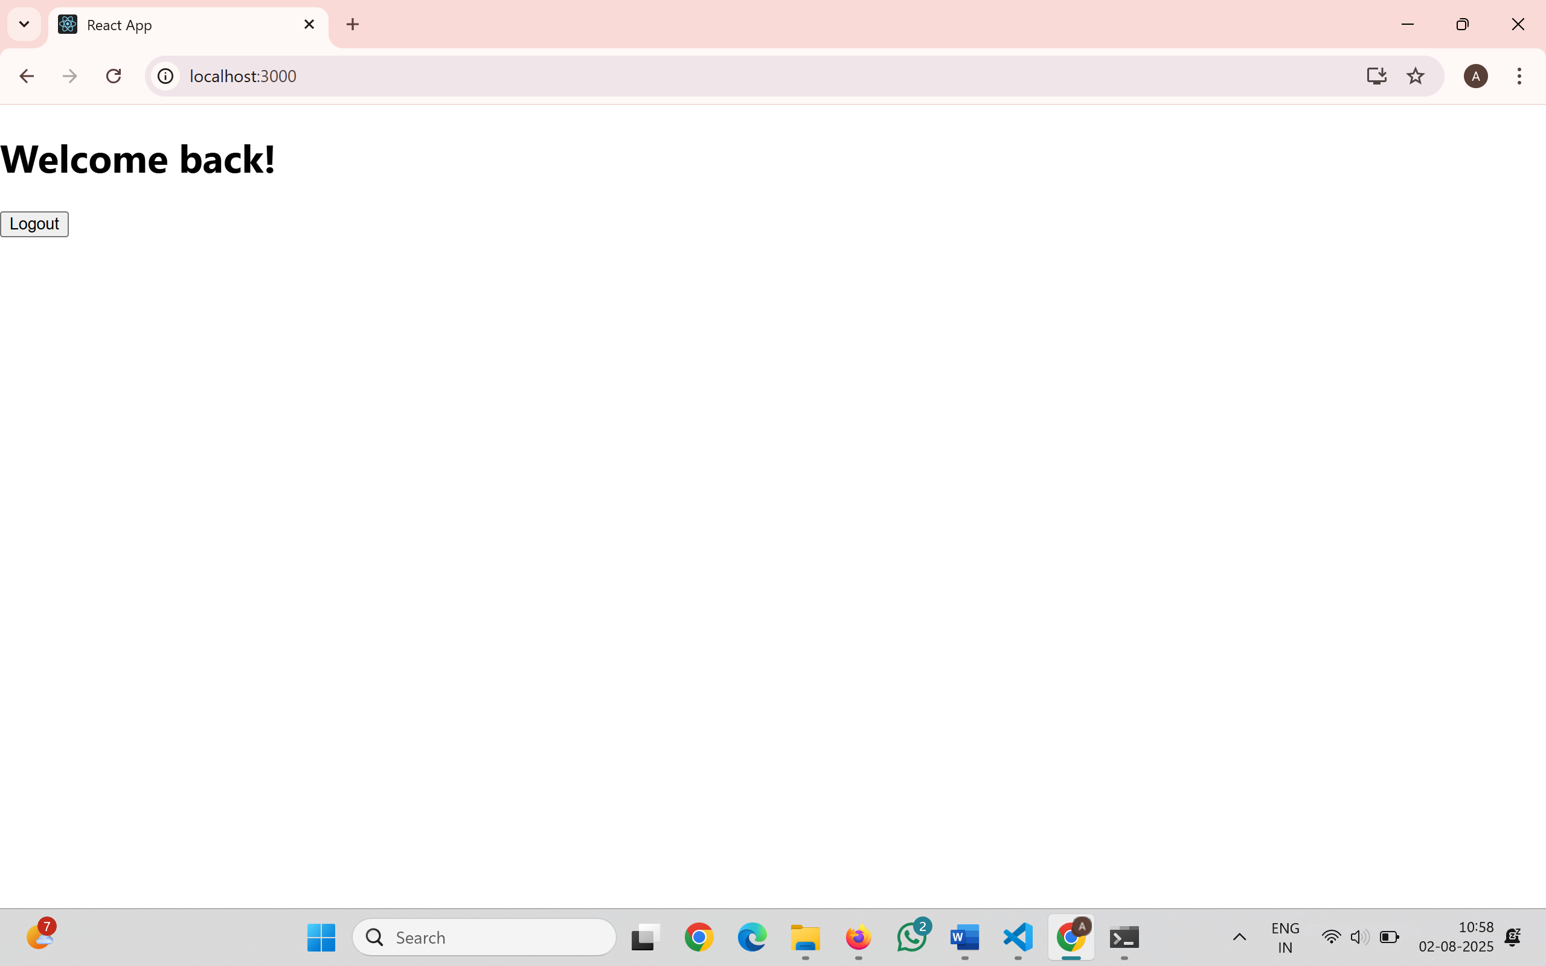
13. ReactJS-HOL
Create a React App named “bloggerapp” in with 3 components.
- Book Details
- Blog Details
- Course Details
book.js
export const books = [
{ id: 101, bname: 'Master React', price: 670 },
{ id: 102, bname: 'Deep Dive into Angular 11', price: 800 },
{ id: 103, bname: 'Mongo Essentials', price: 450 }
];
blog.js
export const blogs = [
{ id: 1, title: 'React Learning', author: 'Stephen Biz', desc: 'Welcome to learning React!' },
{ id: 2, title: 'Installation', author: 'Schwezdenier', desc: 'You can install React from npm.' }
];
course.js
export const courses = [
{ id: 1, name: 'Angular', date: '4/5/2021' },
{ id: 2, name: 'React', date: '6/3/20201' }
];
App.js
import React from 'react';
import { books } from './book';
import { blogs } from './blog';
import { courses } from './course';
import './App.css';
function App() {
return (
<div className="main-container">
<div className="section">
<h2>Course Details</h2>
{courses.map((course) => (
<div key={course.id}>
<h3>{course.name}</h3>
<p><strong>{course.date}</strong></p>
</div>
))}
</div>
<div className="divider"></div>
<div className="section">
<h2>Book Details</h2>
{books.map((book) => (
<div key={book.id}>
<h3>{book.bname}</h3>
<p><strong>{book.price}</strong></p>
</div>
))}
</div>
<div className="divider"></div>
<div className="section">
<h2>Blog Details</h2>
{blogs.map((blog) => (
<div key={blog.id}>
<h3>{blog.title}</h3>
<p><strong>{blog.author}</strong></p>
<p>{blog.desc}</p>
</div>
))}
</div>
</div>
);
}
export default App;
App.css
.main-container {
display: flex;
align-items: stretch;
padding: 40px;
}
.section {
width: 250px;
padding: 0 20px;
display: flex;
flex-direction: column;
}
.divider {
width: 3px;
background-color: green;
}
h2 {
font-size: 24px;
font-weight: bold;
margin-bottom: 20px;
}
.item-title {
font-size: 20px;
font-weight: bold;
margin-bottom: 5px;
}
.item-subtext {
font-size: 16px;
font-weight: normal;
margin-bottom: 15px;
}
Output:
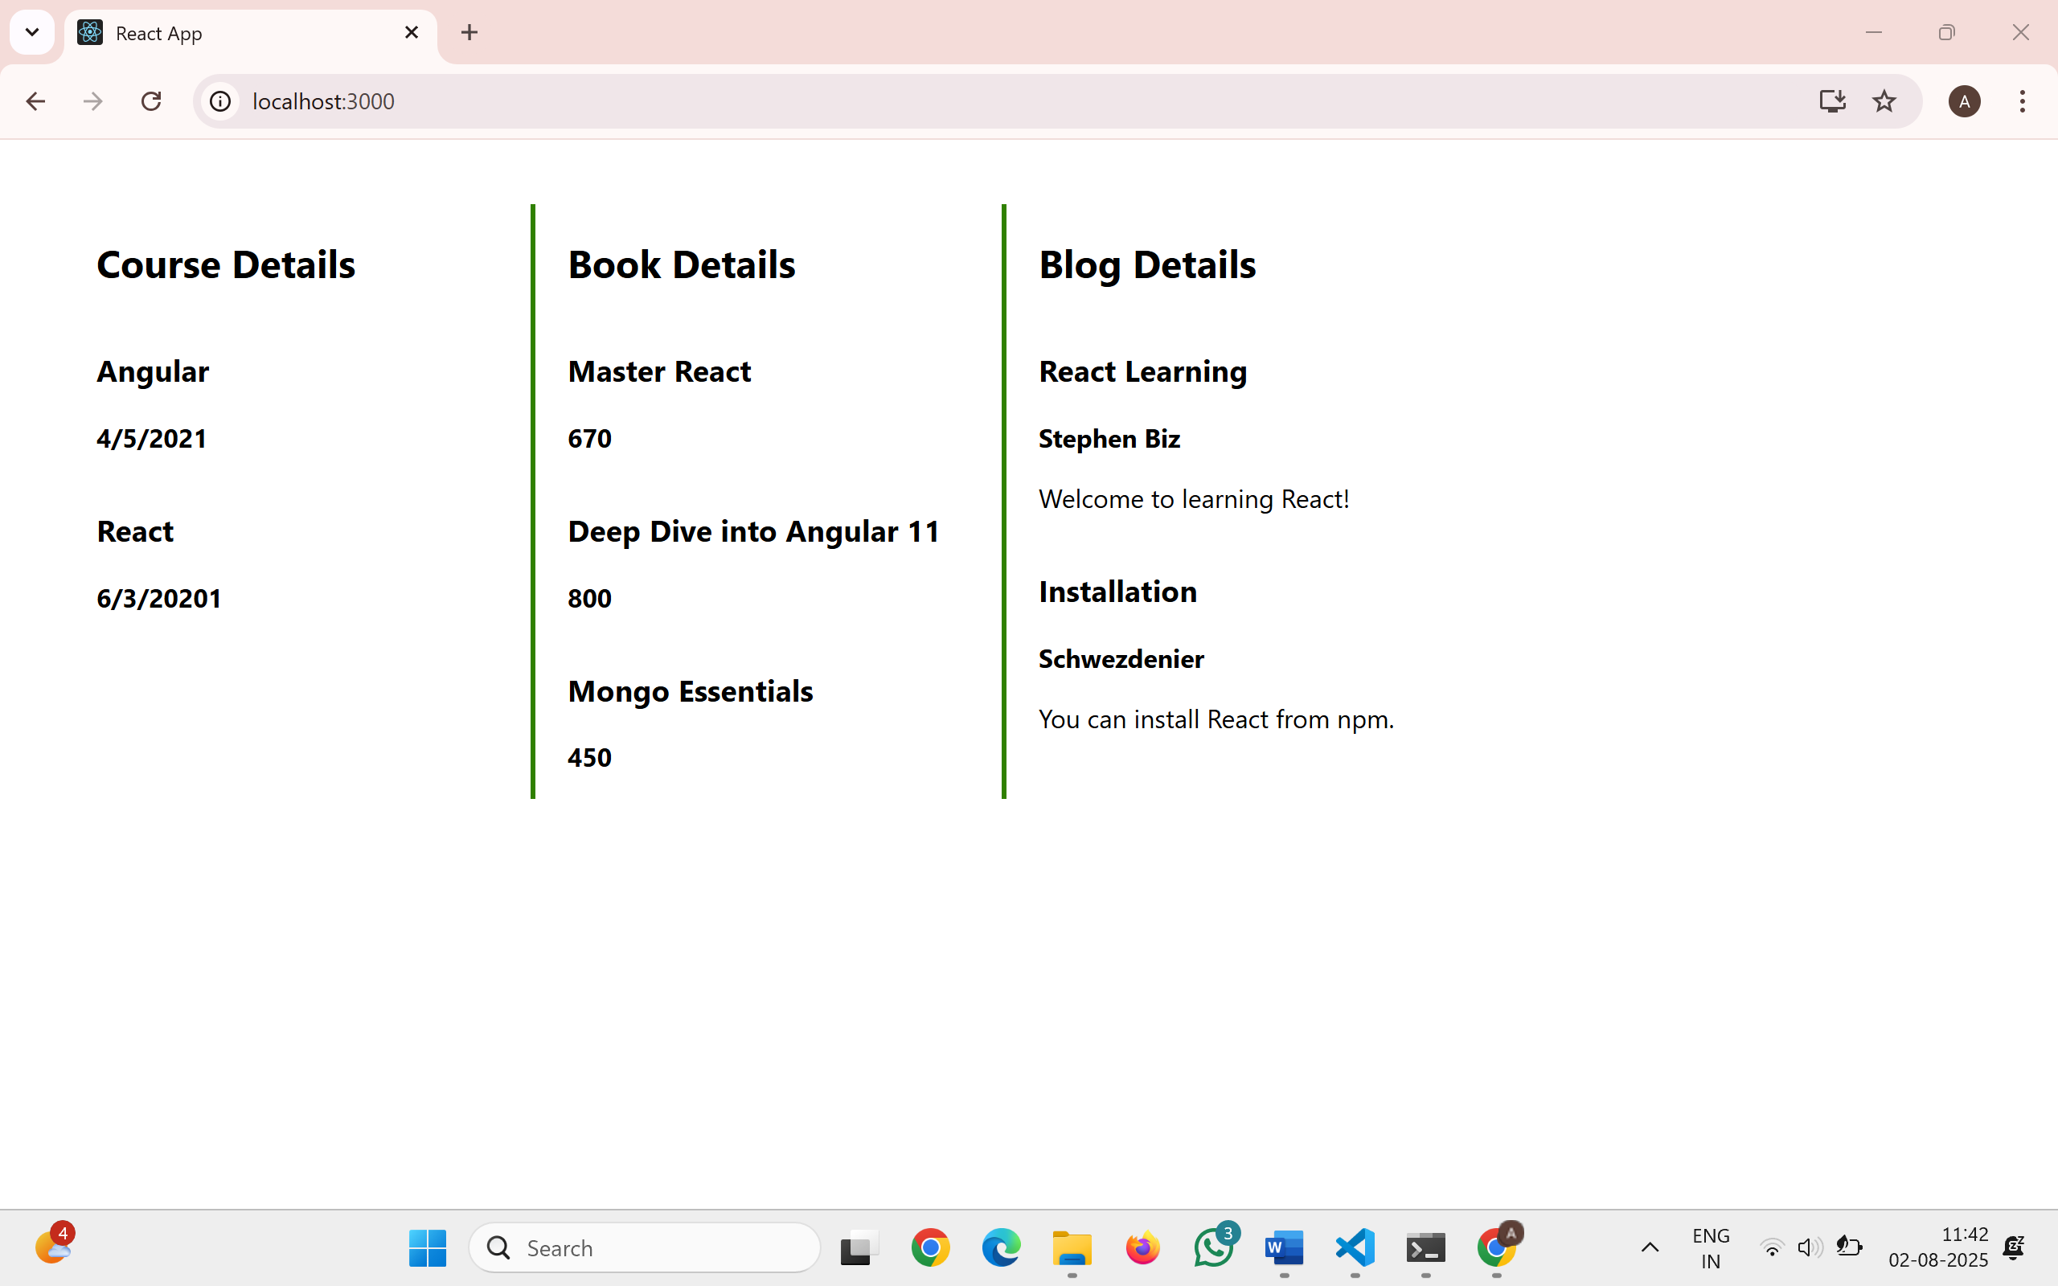
14. ReactJS-HOL
ThemeContext.js
import { createContext } from 'react';
const ThemeContext = createContext('light'); // Default value
export default ThemeContext;
EmployeeCard.js
import React, { useContext } from 'react';
import ThemeContext from './ThemeContext';
function EmployeeCard({ employee }) {
const theme = useContext(ThemeContext); // Using context
return (
<div className={`card ${theme}`}>
<h3>{employee.name}</h3>
<p>{employee.designation}</p>
<button className={`btn ${theme}`}>View</button>
</div>
);
}
export default EmployeeCard;
EmployeesList.js
import React from 'react';
import EmployeeCard from './EmployeeCard';
function EmployeesList() {
const employees = [
{ id: 1, name: 'Alice Margon', designation: 'Developer' },
{ id: 2, name: 'John Doe', designation: 'Designer' }
];
return (
<div>
{employees.map(emp => (
<EmployeeCard key={emp.id} employee={emp} />
))}
</div>
);
}
export default EmployeesList;
App.js
import React, { useState } from 'react';
import EmployeesList from './EmployeesList';
import ThemeContext from './ThemeContext';
function App() {
const [theme, setTheme] = useState('light');
return (
<ThemeContext.Provider value={theme}>
<div>
<h1>Employee Management</h1>
<EmployeesList />
</div>
</ThemeContext.Provider>
);
}
export default App;
Output:
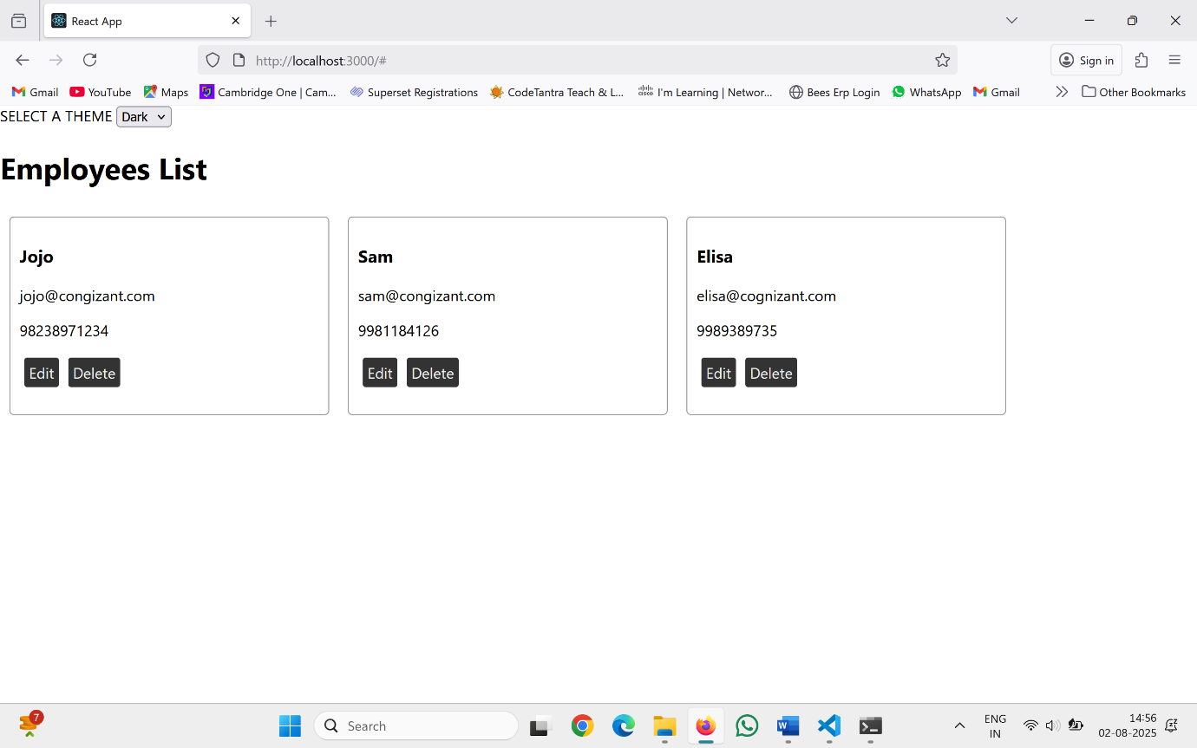
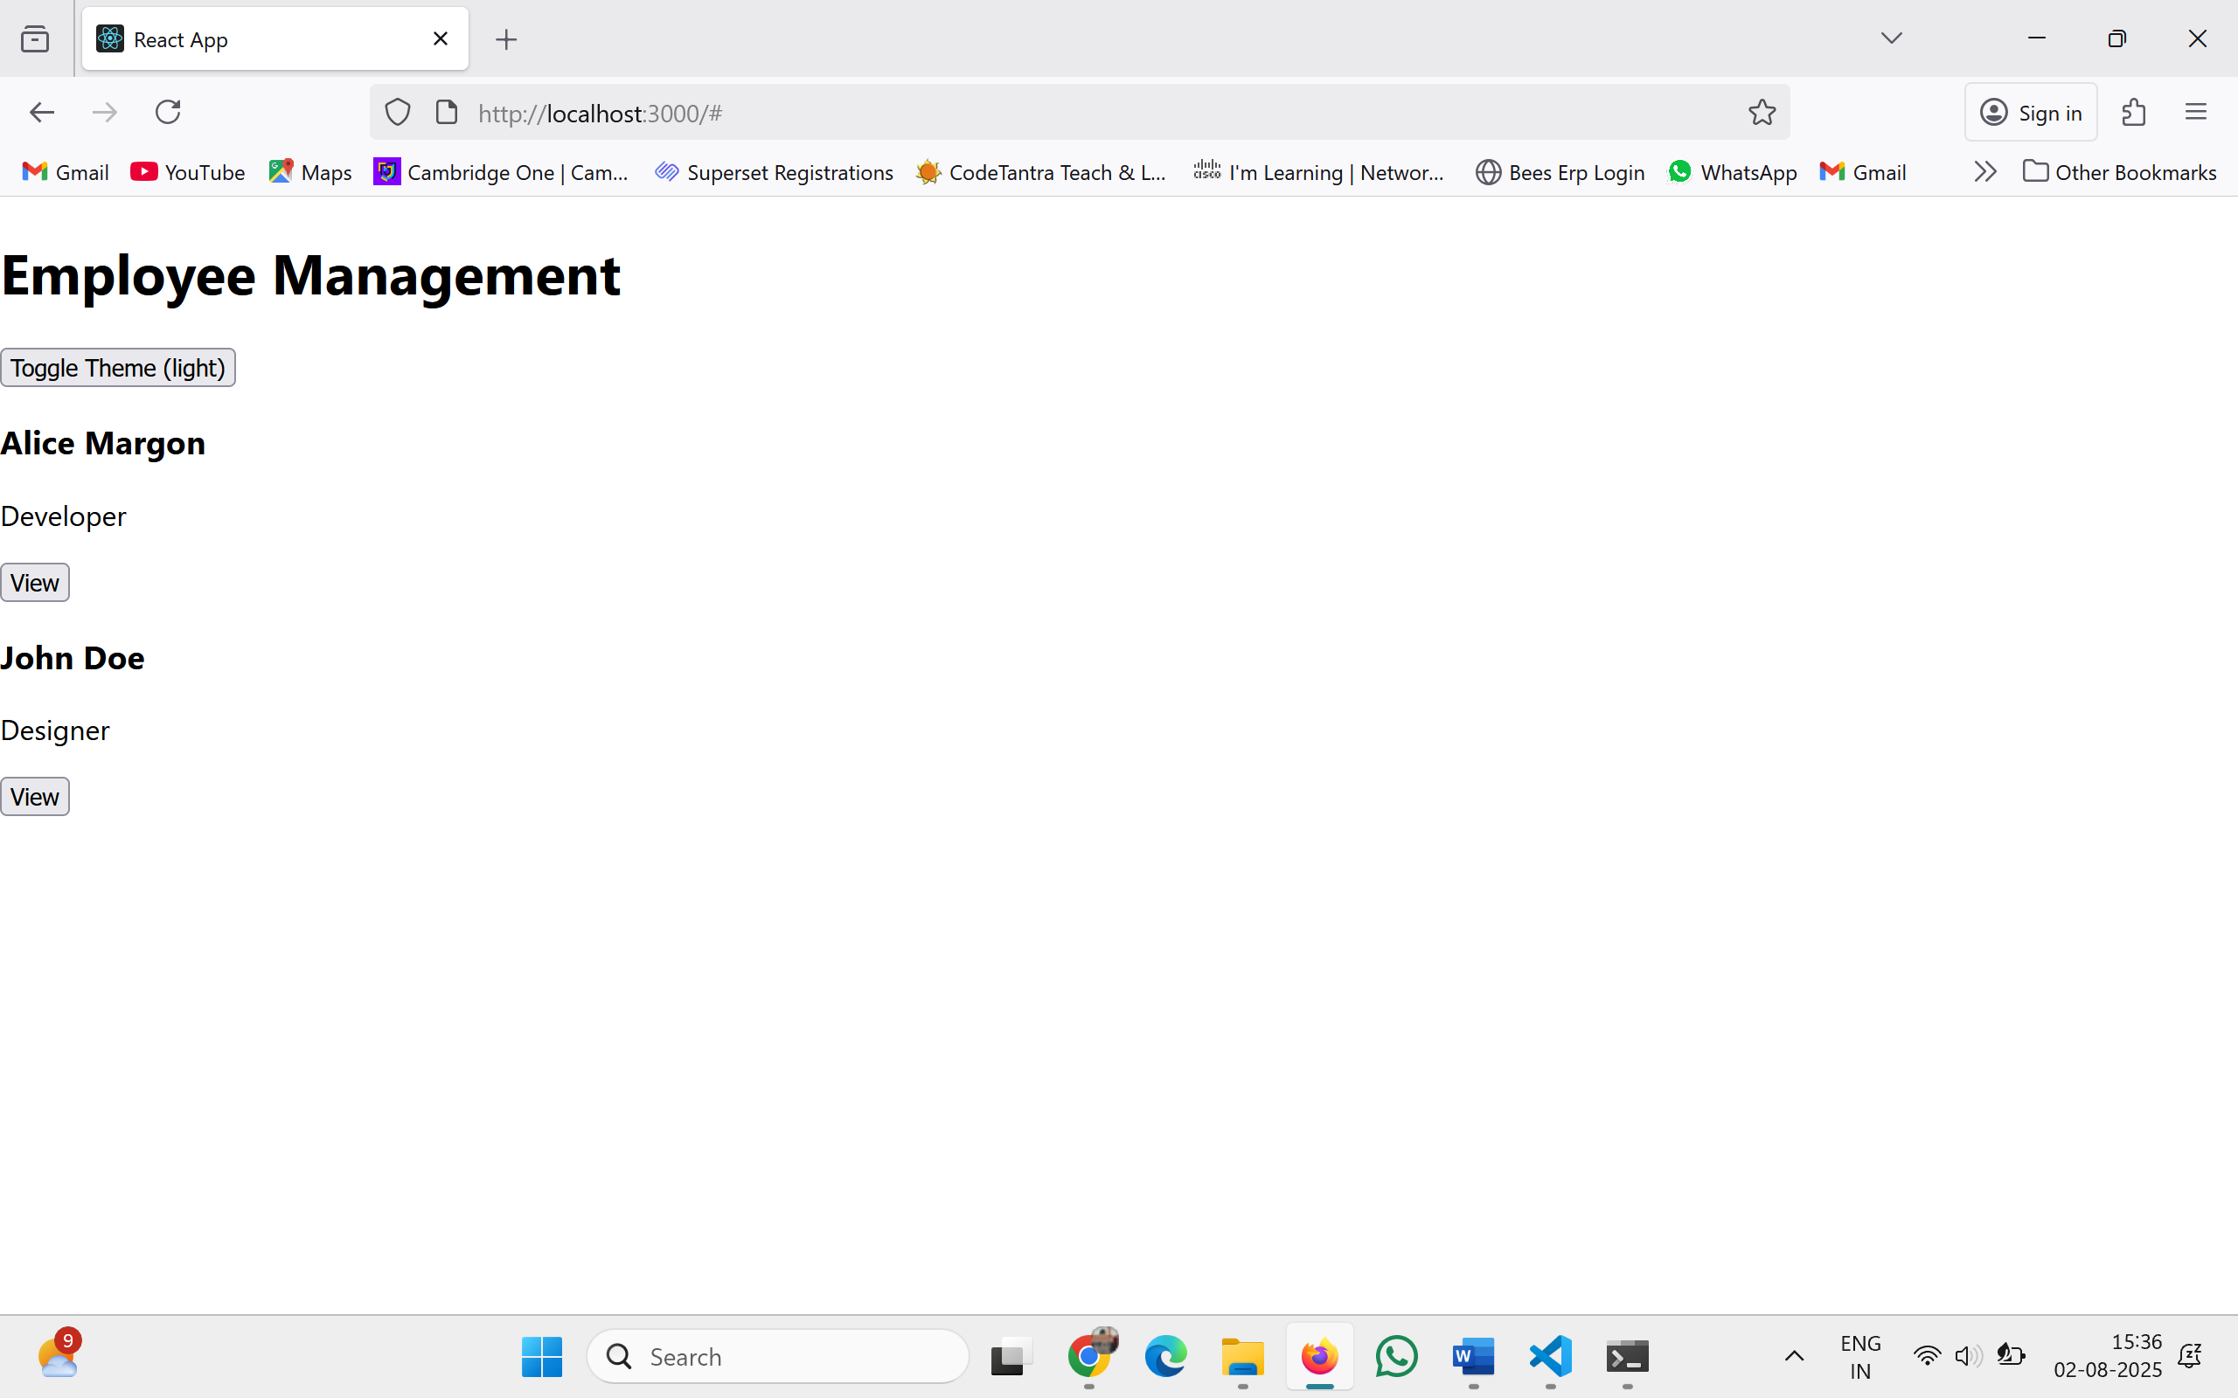
15. ReactJS-HOL
Create a React App named “ticketraisingapp” which will help to raise a complaint and get it resolved.
ComplaintRegister.js
import React, { Component } from 'react';
class ComplaintRegister extends Component {
constructor(props) {
super(props);
this.state = {
ename: '',
complaint: '',
NumberHolder: ''
};
}
handleChange = (event) => {
const { name, value } = event.target;
this.setState({ [name]: value });
}

handleSubmit = (event) => {
event.preventDefault();
const referenceNumber = Math.floor(100000 + Math.random() * 900000);
this.setState({ NumberHolder: referenceNumber }, () => {
alert(`Thanks ${this.state.ename}!\nYour Complaint was submitted.\nTransaction ID: ${this.state.NumberHolder}`);
});
this.setState({ ename: '', complaint: '' });
}
render() {
return (
<div style={{ padding: '20px', fontFamily: 'Arial' }}>
<h2 style={{ color: 'red' }}>Register your complaints here!!!</h2>
<form onSubmit={this.handleSubmit}>
<div style={{ display: 'flex', alignItems: 'center', marginBottom: '10px' }}>
<label style={{ width: '100px' }}>Name:</label>
<input
type="text"
name="ename"
value={this.state.ename}
onChange={this.handleChange}
required
style={{ flex: 1, padding: '6px' }}
/>
</div>
<div style={{ display: 'flex', alignItems: 'center', marginBottom: '10px' }}>
<label style={{ width: '100px' }}>Complaint:</label>
<textarea
name="complaint"
value={this.state.complaint}
onChange={this.handleChange}
required
style={{ flex: 1, padding: '6px', height: '80px' }}
/>
</div>
<button type="submit" style={{ padding: '8px 16px' }}>Submit</button>
</form>
</div>
);
}
}
export default ComplaintRegister;
App.js
import React from 'react';
import ComplaintRegister from './ComplaintRegister';

function App() {
return (
<div className="App">
<ComplaintRegister />
</div>
);
}
export default App;
App.css
.App {
font-family: sans-serif;
padding: 20px;
max-width: 600px;
margin: auto;
}
input, textarea {
width: 100%;
padding: 8px;
margin-top: 5px;
box-sizing: border-box;
}
button {
padding: 10px 15px;
background-color: #1976d2;
color: white;
border: none;
cursor: pointer;
}
Output
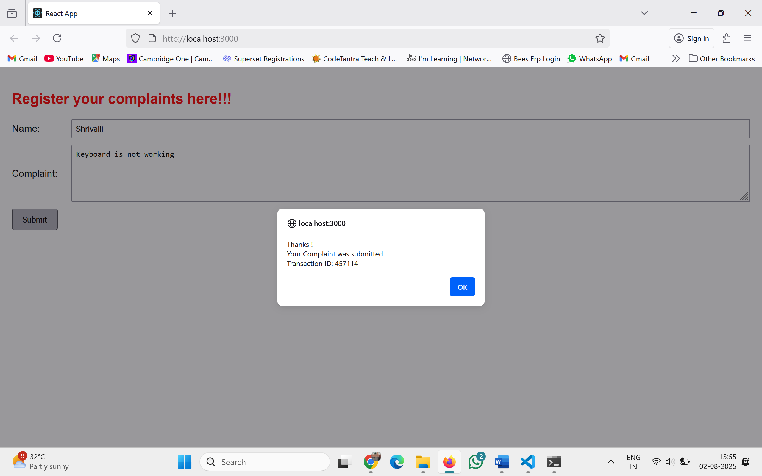

16. ReactJS-HOL
Create a React App named “mailregisterapp” which will have a component named “register.js”.
register.js
import React, { Component } from 'react';
class Register extends Component {
constructor(props) {
super(props);
this.state = {
fullName: '',
email: '',
password: '',
errors: {
fullName: '',
email: '',
password: ''
}
};
}
handleChange = (event) => {
const { name, value } = event.target;
let errors = this.state.errors;
switch (name) {
case 'fullName':
errors.fullName =
value.length < 5 ? 'Full Name must be 5 characters long!' : '';
break;
case 'email':
errors.email =
!value.includes('@') || !value.includes('.')
? 'Email must include @ and .'
: '';
break;
case 'password':
errors.password =
value.length < 8 ? 'Password must be at least 8 characters!' : '';
break;
default:
break;
}
this.setState({ [name]: value, errors });
};
validateForm = (errors) => {
return (
errors.fullName === '' &&
errors.email === '' &&
errors.password === ''
);
};
handleSubmit = (event) => {
event.preventDefault();
const { errors } = this.state;
if (this.validateForm(errors)) {
alert('Valid Form');
this.setState({
fullName: '',
email: '',
password: '',
errors: {
fullName: '',
email: '',
password: ''
}
});
} else {
if (errors.fullName !== '') {
alert(errors.fullName);
}
if (errors.email !== '') {
alert(errors.email);
}
if (errors.password !== '') {
alert(errors.password);
}
}
};
render() {
const { fullName, email, password } = this.state;
return (
<form onSubmit={this.handleSubmit}>
<h2 style={{ color: 'red' }}>Register Here!!!</h2>
<label>Name:</label><br />
<input
type="text"
name="fullName"
value={fullName}
onChange={this.handleChange}
/><br /><br />
<label>Email:</label><br />
<input
type="text"
name="email"
value={email}
onChange={this.handleChange}
/><br /><br />
<label>Password:</label><br />
<input
type="password"
name="password"
value={password}
onChange={this.handleChange}
/><br /><br />
<button type="submit">Submit</button>
</form>
);
}
}
export default Register;
App.js
import React from 'react';
import Register from './register';
function App() {
return (
<div className="App">
<Register />
</div>
);
}
export default App;
Output:
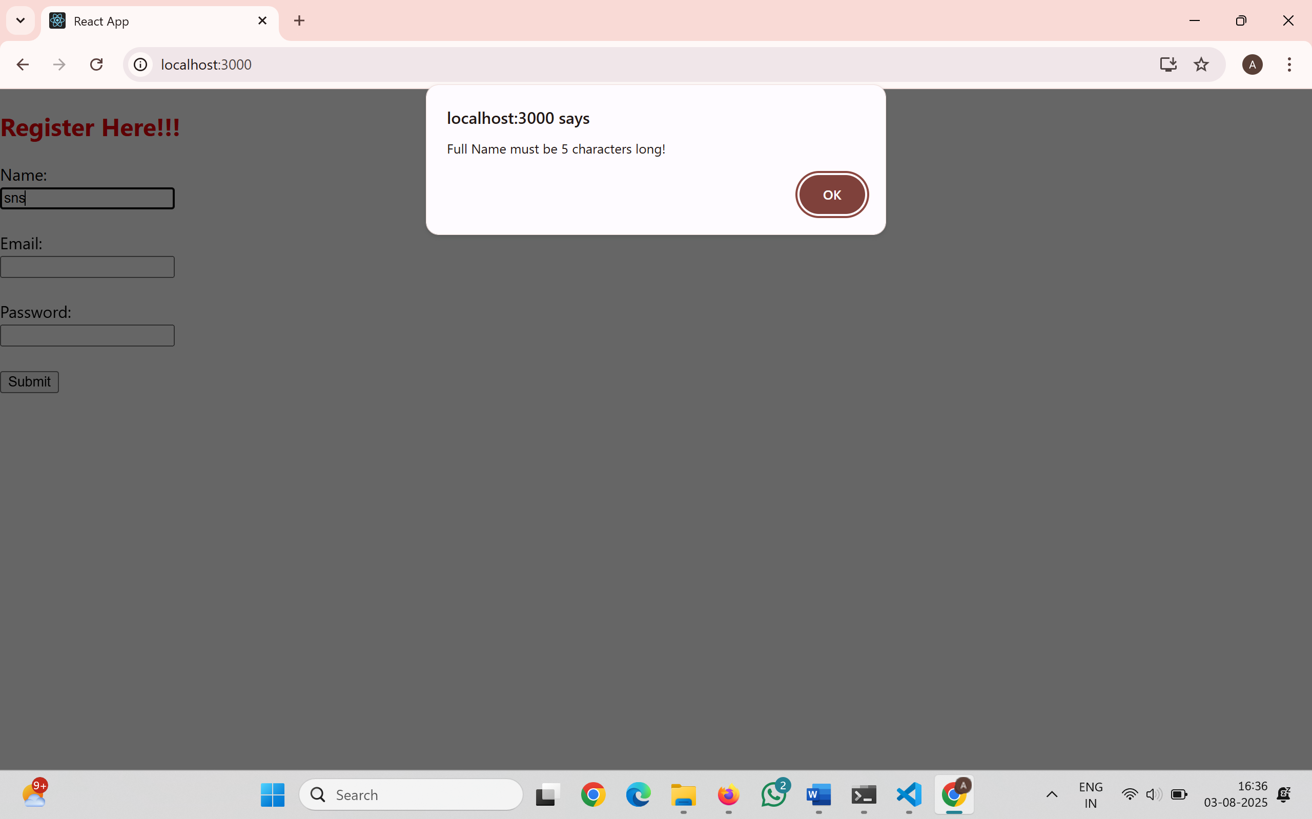
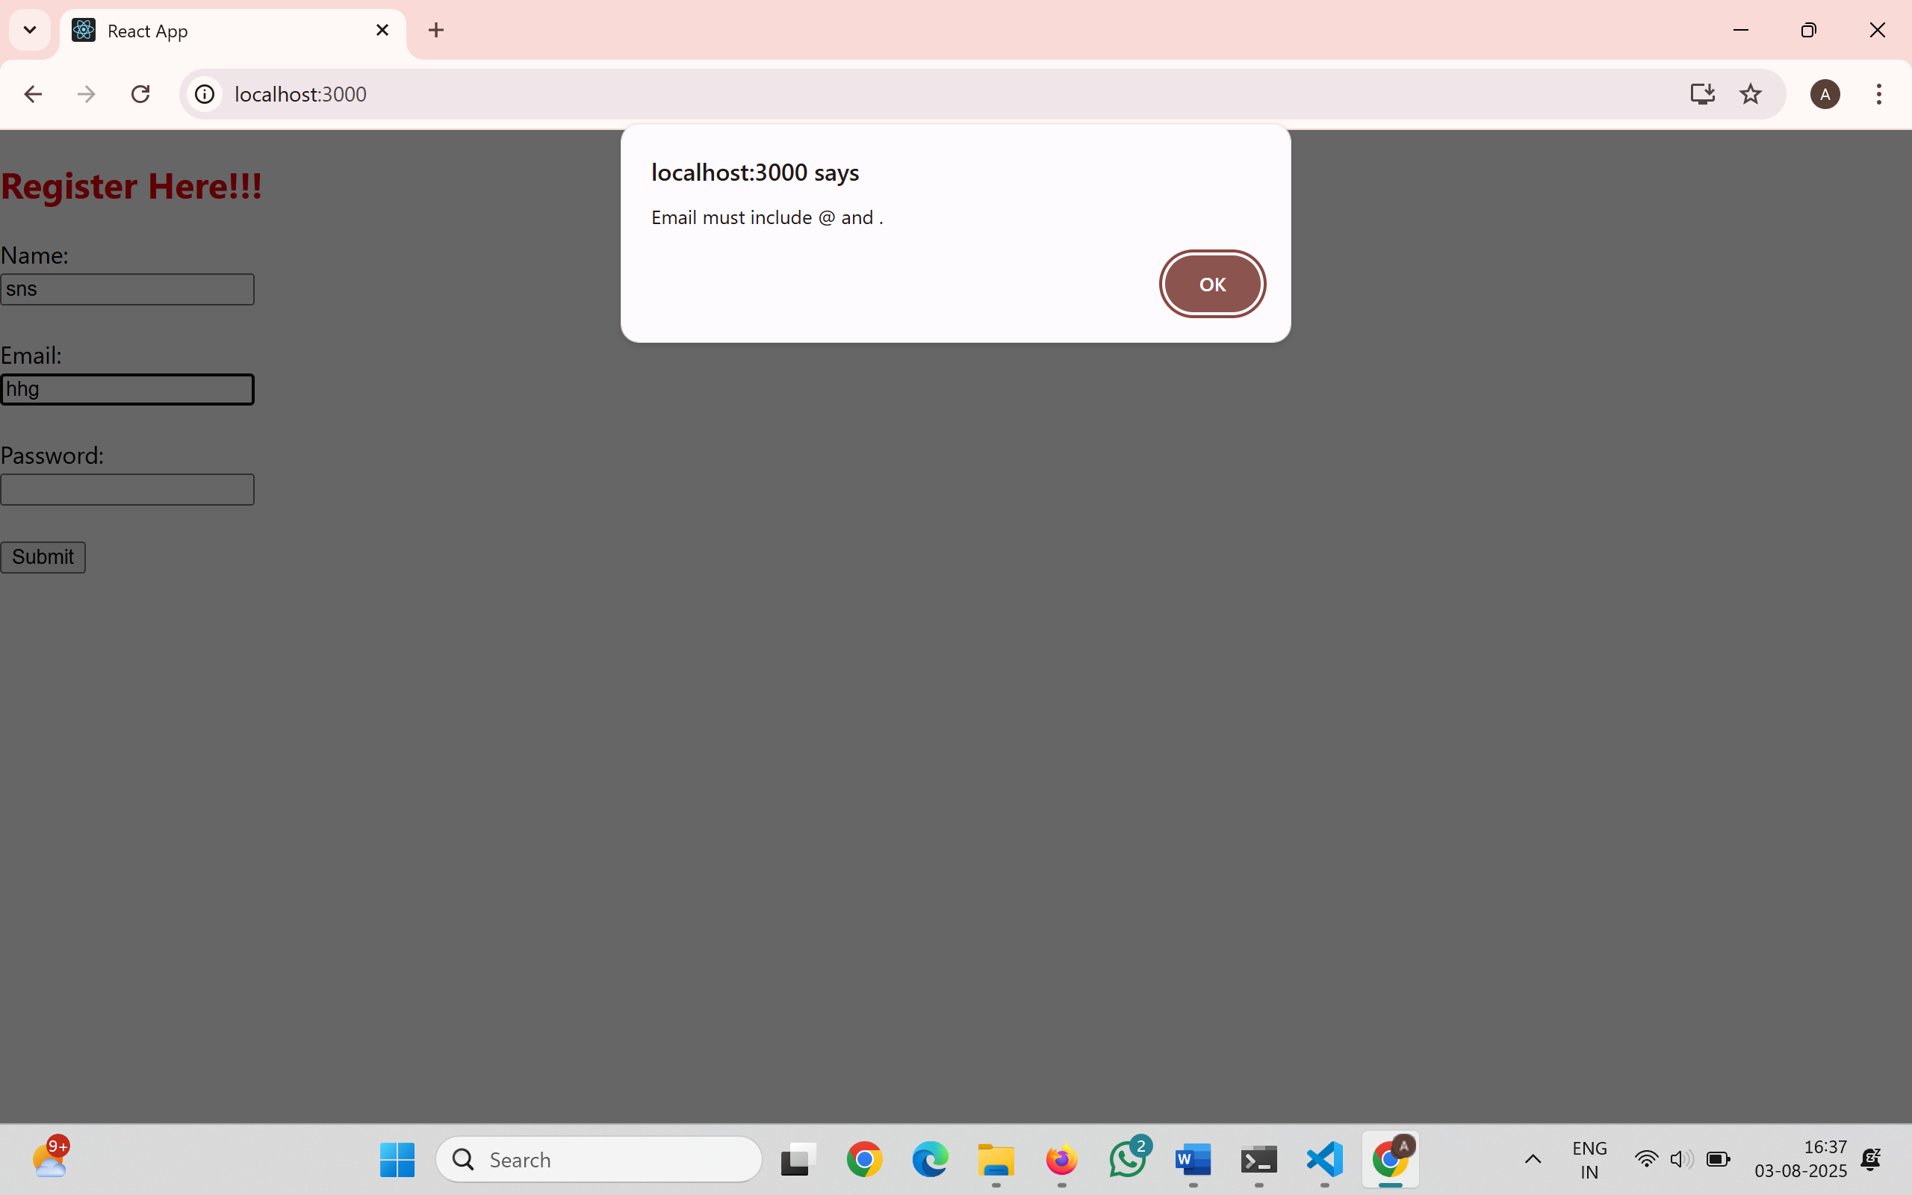
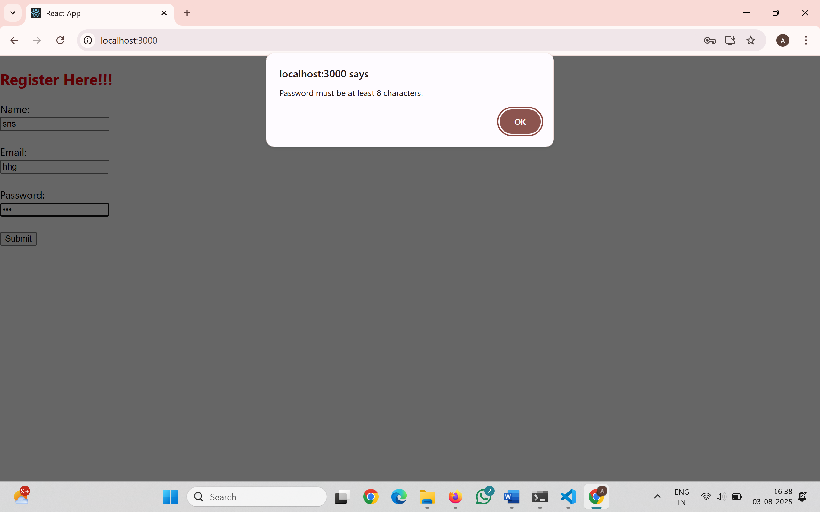
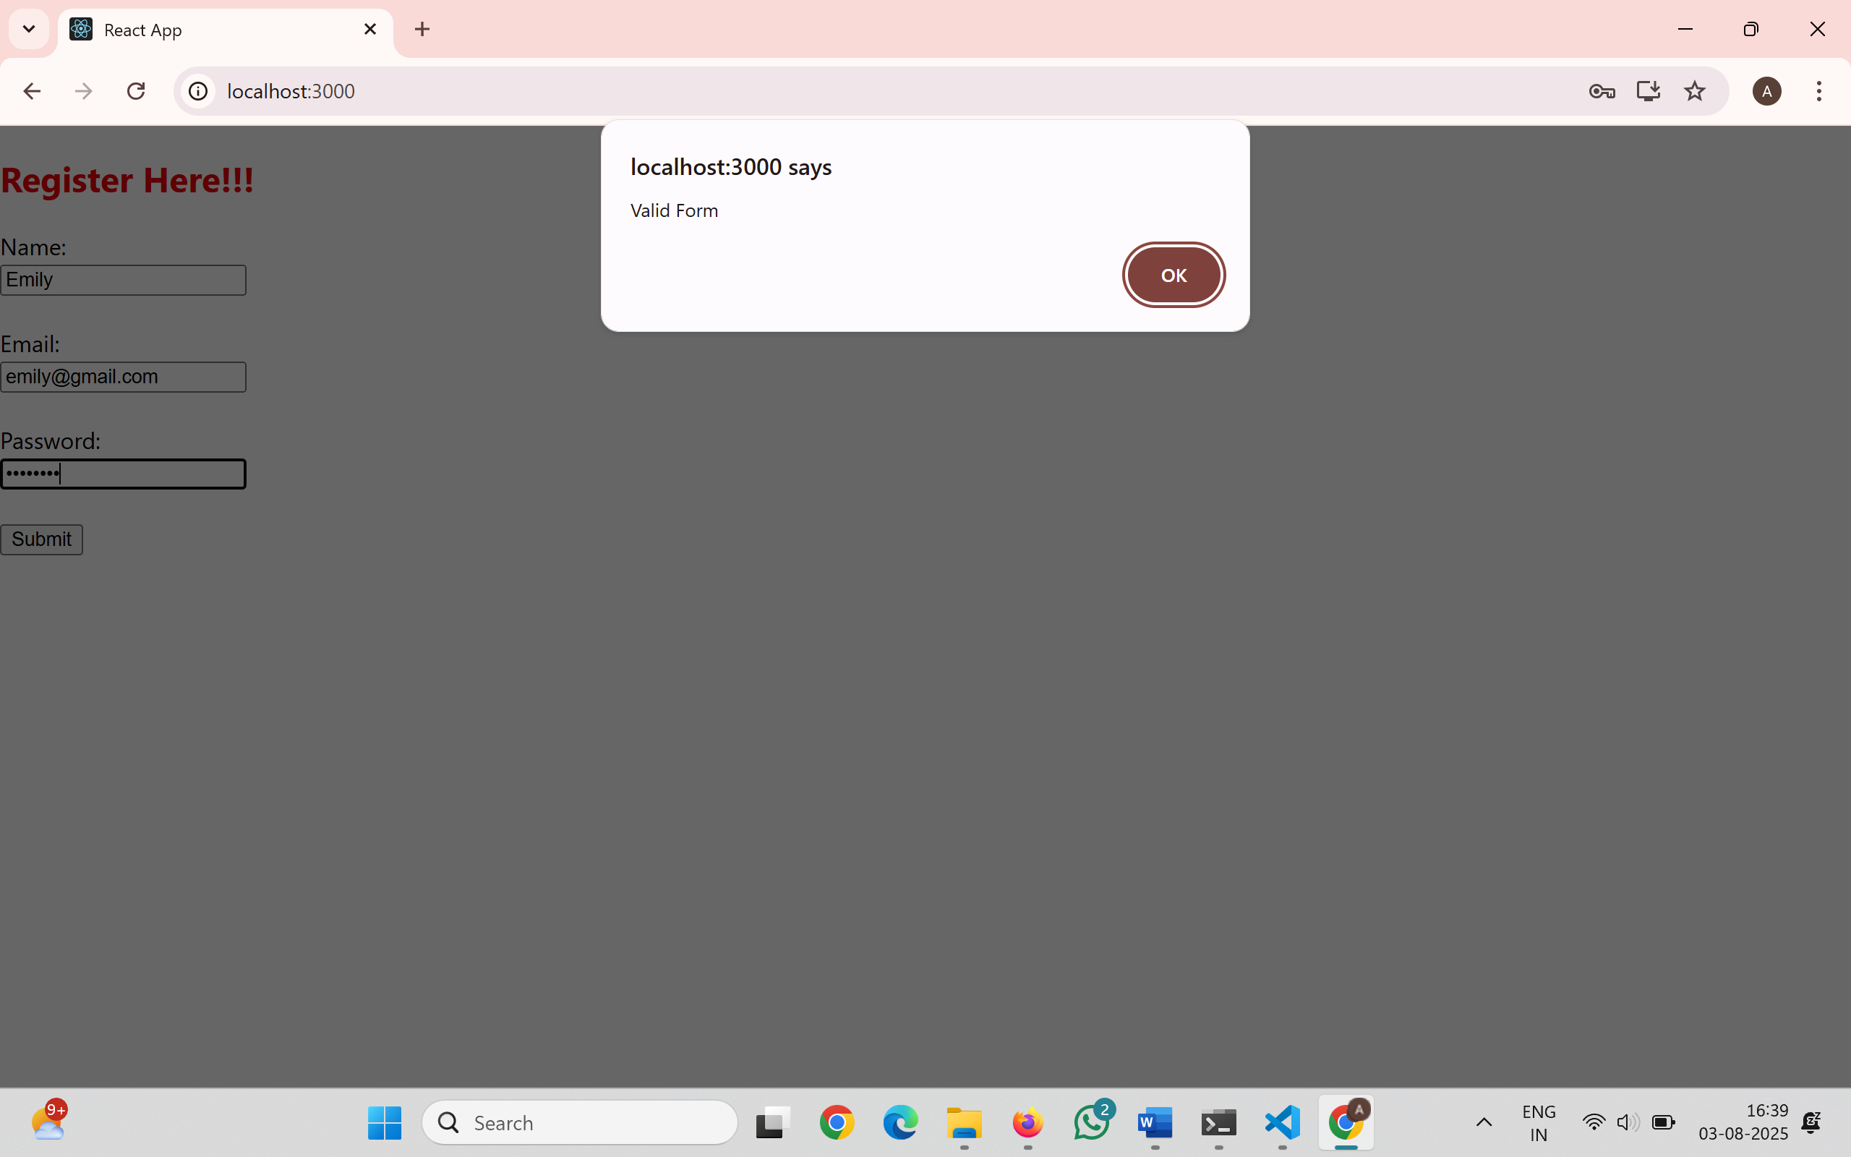
17. ReactJS-HOL
Create a React Application “fetchuserapp” which will retrieve the user details from https://api.randomuser.me/ and display the title, firstname and image of a user.
Getuser.js
import React, { Component } from 'react';
class Getuser extends Component {
constructor(props) {
super(props);
this.state = {
person: {},
loading: true
};
}
async componentDidMount() {
const url = "https://api.randomuser.me/";
const response = await fetch(url);
const data = await response.json();
this.setState({ person: data.results[0], loading: false });
console.log(data.results[0]);
}
render() {
const { loading, person } = this.state;
if (loading) {
return <h2>Loading...</h2>;
}
return (
<div style={{ textAlign: 'center', marginTop: '40px' }}>
<h1>
{person.name.title} {person.name.first} {person.name.last}
</h1>
<img src={person.picture.large} alt="User" />
</div>
);
}
}
export default Getuser;
App.js
import React from 'react';
import Getuser from './Getuser';
function App() {
return (
<div className="App">
<Getuser />
</div>
);
}
export default App;
Output:
